The Senior Management Qualitech Environmental Services Ltd believes that delivering products and services which not only satisfies the customer's requirements but exceeds their expectations is paramount in providing a quality service. Senior Management are also resolved that the business activities of the company shall be carried out with due regard to the effects they may have on the environment. To this end, the Management Team have put in place a business management system which complies with the international Standards EN ISO 9001:2015 and EN ISO 14001:2015 and is committed to complying with the requirements of the system and the standards.

Senior Management understand the importance of developing the business management system and are committed to ensuring continual improvement of the system, compliance with applicable legal requirements (including other applicable requirements relating to the environmental aspects), and prevention of pollution. As a means of ensuring this continual improvement, objectives shall be compiled, and appropriate programmes put in place to deliver these objectives. Adequate resources will be put into all areas of the company's operations to ensure that the business management system is adequately maintained and developed, and works are completed on time and to the customer's satisfaction. It is the company's intention to minimise time and material losses from scrap, badly planned work, poor communications and inefficient operations.

In pursuit of this policy, Senior Management will ensure that customer requirements are fully understood on all contracts and adequately communicated to employees in order that the customer expectations are not only achieved but enhanced. Methodologies will be put in place to measure and monitor customer satisfaction, compliance with legislation and establishment of environmental aspects. Senior management will regularly review and analyse the findings and take appropriate action.

In order to ensure that all staff and sub-contractors understand the importance of good quality workmanship and the need to minimise environmental pollution from their activities, the company will provide any training and instruction necessary and will monitor its effectiveness.

Signed by the person responsible for
Quality and Environmental Issues
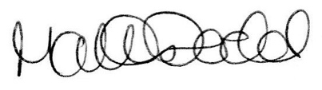

Director

